Great Lakes Environmental Festival April 21-22, 2023
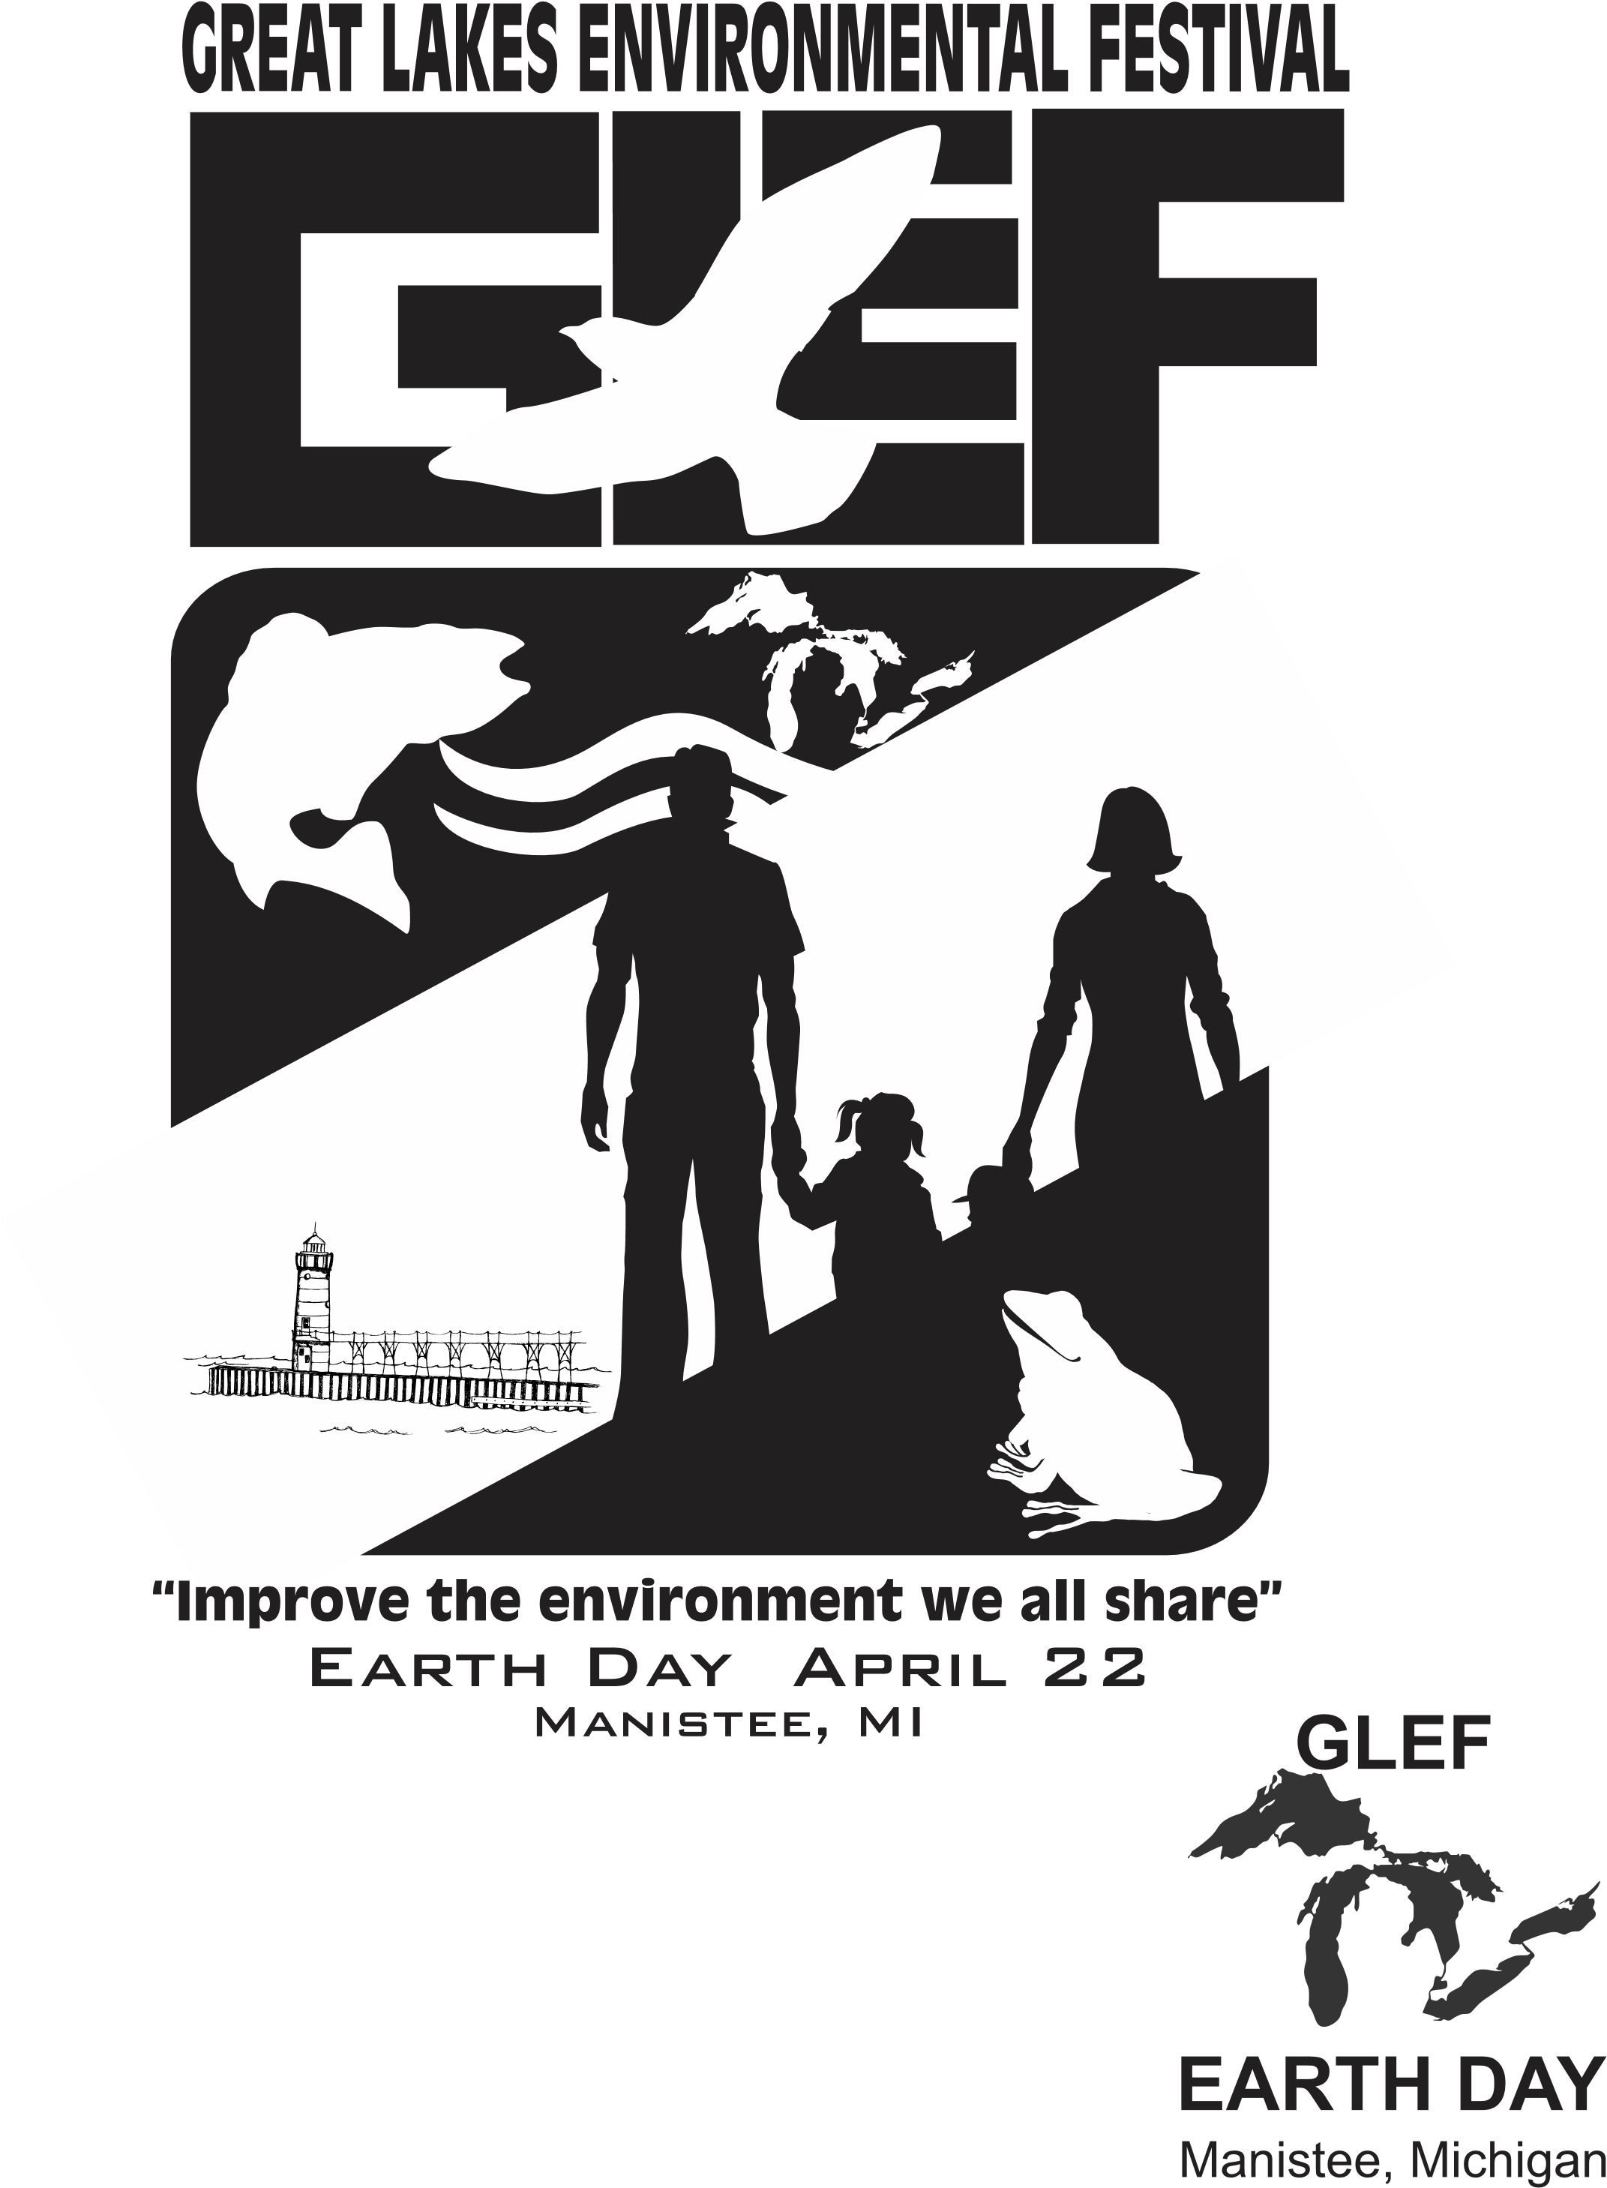
GLEF is a 501(c)3.
Location Manistee, Michigan
Manistee is a city in the U.S. state of Michigan located on Lake Michigan. The name "Manistee" is from an Ojibwe word first applied to the principal river of the county. The derivation is not certain, but it may be from ministigweyaa, "river with islands at its mouth." Other sources claim that it was an Ojibwe term meaning "spirit of the woods."
This is multi day annual festival is scheduled during Earth Day week. Earth Day is an annual event celebrated around the world on April 22 to demonstrate support for environmental protection. First celebrated in 1970, it now includes events coordinated globally by the Earth Day Network in more than 193 countries.

Meeting Minutes: March 19, 2023 at 7:00 Zoom Meeting

In attendance via Zoom were:
Stephanie Baiyasi stephaniebaiyasi@yahoo.com 989-450-6110
Ziggy Kozicki zigpsych@sbcglobal.net 989-450-1451
John Helge Johnmhelge@gmail.com 616-915-2403
Judy Cunningham jpc4466@gmail.com 231-794-0005
Shirley Madden gspmadden@gmail.com 313-478-5347
Gary Madden genie42br@gmail.com 313-478-6250
Lee Trucks ltrucks@jackpine.com 231-510-6785
Ramona DeGeorgio-Venegas mona_degeorgio@yahoo.com 231-690-6197

Excused:
Emily McGaffigan eemcgaffigan@gmail.com 231-655-1742
Peggy Raddatz peg.raddatz@gmail.com
Al Frye alfrye55@gmail.com

- 3-14-23 meeting minutes corrected and approved (Stephanie 1st, Judy-2nd). The approved version of the minutes will be sent with these minutes.

Old Business
Schedule for GLEF 2023 is just about set. A few spots open for speakers.
Assignments have been given.
Update Vision and Mission Statement. THE VISION OF THIS ORGANIZATION IS TO "IMPROVE THE ENVIRONMENT WE ALL SHARE." THE MISSION IS TO "PROVIDE AWARENESS THAT LEADS TO ACTION BY PEOPLE TO BETTER MANAGE THE ENVIRONMENT". ESTABLISHED IN 2008 THE GREAT LAKES ENVIRONMENTAL FESTIVAL (GLEF) PURPOSE IS TO PROMOTE COMMUNITY ACTIVITIES, MEDIA, AND DISPLAYS TO INVOLVE THE PUBLIC ESPECIALLY STUDENTS AND EDUCATORS IN ENVIORONMENTAL STEWARDSHIP. THE FESTIVAL IS EXPECTED TO INSPIRE OTHER PEOPLE TO THINK ABOUT ECOLOGY AND THE VALUE OF NATURAL RESOURCES OF THE GREAT LAKES REGION.
Web Page
The web site GLEF.us is now the official connection for people to see planned events, volunteer and to donate to GLEF.
Facebook
Downtown Manistee has posted the GLEF schedule https://www.facebook.com/downtownmanistee/posts/
People can join Facebook and follow GLEF at https://www.facebook.com/GR8FESTIVAL/
New Business/Discussion
- April 8 – Beach clean-up on 1st Street at 11am. There will be a Lake MI section , a Manistee river section and river walk. Volunteers should show up. Volunteer and encourage people at this event to support GLEF.
- Dial-A-Ride was discussed $52/hr * 7 hrs = $364 total cost. Decision to use still in deliberation.
- Coffee and donuts not required for event.
- John Helge to ask for $500 donation from Meijer
- John Helge will cover cost of Wagoner Center ($200), Gary will try to work this price down during his meeting with Wagoner people.
- John Helge to follow up on art teacher display of student work at WSCC
- John Helge is talking with science teachers.
- John Helge’s Unitarian Church is Obama’s Church which promotes open service and they will host April 23 morning service.
- Ziggy has two student posters about environment to display at WSCC.
- Three student video are submitted.
- Yard signs to promote Earth Day discussed; we could also sell these at EXPO ($10 or $15 donation?) Use Jackpine
- Extra GLEF shirts from 2022 will be for sale at event.
- Flyers to Dublin store were discussed. Ramona will reach out to Teachers in Brethren and Dublin store.
- Gary discussed video of Ann Arbor family home. @nd half of video is OK, but having the owners speak via ZOOM would be better. Gary will connect. Microplastics with John = good; master’s degree in Env. Science
- Gary offered weekend at his rental (450 ft²) as a “door prize” for a donation ($5 minimum)
- Coffee and donuts? Groups decided to NIX
- Gary to talk to Coast Guard Commander who will receive Guardian of Lakes Award
- Gary to talk with Coast Guard about River Rescue Details
- Letters to editor – we need these to be sent! Multiple options include Northern Express, Senior Moments, Bulletin Board News
- Judy to write to editor – “add to bulletin board”
- Gary to write to Senior Moments
- Manistee Green ?
- Northern Express?
- Shirley will write to Fresh Water
- Manistee Visitors Bureau visited by Ziggy and they are closed.
- Ziggy has contacted Manistee library and bookstore left flyers about Earth Day.
- Ziggy spoke with Connie the CFO at WSCC who took flyers and is going to promote WSCC involvement in 2023 event. She thinks this event is a good fit for the students and faculty.
- Ziggy Left message for WSCC Student Government for Emily
- Ziggy spoke to MESC and they are aware of the event.
- Flyers have been distributed to River Street Merchants by Ziggy
- Big Al’s now has 500 Pizza Box GLEF Flyers to distribute
- Flyers for Family Fare delivered by Ziggy. They will not stuff labels in bags.
- Ziggy will talk to TV/Radio media this week.
- Ziggy and Stephanie ordering Guardian of the Great Lakes Award for Manistee Coast Guard and Little River Band of Ottawa Indians.
- Ziggy has contacted and has secured the following locations for bead distribution:
- Bell Sprouts Children’s Resale Christen 231-655-9770
- Port City Organics Kaylee 231-398-3060
- UP North Collection Luke Coye 231-655-9538
- Nails on River Street Tina 231 398-2685
- Alex Doucetts Fine Bedding & Northern Spirits 231-233-1155
- CC Jewelers Sarah 231-723-4313
- Glicks Becky and Shelly 231-723-1105
- Gold and Silver Exchange Nicki 231-299-5363
- Manistee Public Library Maple Street (231) 723-2519
- Ramona – beads to match color. String given to string up beads. Ramona to have people call John regarding bead need (Vogue, Bookstore, Library). Northern Spirit – sells beads and can order along with drawstring bags. Ramona will teach volunteers how to make wrist bracelet.
- Shelly Doyen at Ideal Kitchen 231-398-9895 will place our mini GLEF flyers in customer bags. Ziggy will deliver to her 100.
- Ramona to do photos. Someone else will help Shirley at Registration. Registration slips need to be created to capture names of attendees. Bags from Dem elections will be used.
- GLEF Registration Table will be at WSCC – to collect name and contact information from public
- GLEF Welcome Table at Wagoner Center and they will be directed to WSCC
- Insurance for Wagoner exhibit not necessary Helge.
- Ziggy will discuss liability insurance issue with GLEF attorney.
- Shirley will follow-up on city/county resolution
- Shirley will follow-up on kid movie to confirm showing of Lorax. Saturday Morning,
- Shirley will check on cost of making a Earth Day banner.
- Volunteers will start 1 hour before each event on 4.21.& 4.22.
- Gary to research about yard signs for community and to sell at Earth Day by Jack Pine
- Chamber – Gary will check to put GLEF on Chamber website
- Mark Miller, Dylan Walker are supportive and excited about GLEF
- Ziggy is exploring social media promotions.
- North Channel Brewery – Sat 6pm to debrief gathering following events on Earth Day being developed by Ziggy
- Ziggy and Stephanie will make visit to TV 9 & 10
- Ziggy and Stephanie are making media appearances as available.
- Gary and Shirley are making contact with NPR Interlochen
- Electric vehicle rally still being planned.
- Shirley gathering coupons from local business to distribute.
- Name Tags are for GLEF volunteers.
- Liquor Store across from WSCC reminded me not to park in their parking lot.
- The Ideal Kitchen Shelly Doyen 231-398-9895 would like to be involved in 2024 event.
- We need volunteers.
- Should we take shirt and sign orders at event?
- Everyone involved needs to share flyer and GLEF news with people in their immediate circle.
- Do we want to consider a silent auction to raise funds?
- Do you know of any business people who would like to become sponsors?

Next scheduled Zoom meeting Sun. March 26, 7:00 PM

